**WITH NOISE AND WITH FILTER**

**Image set:**

|  |
| --- |
| **Image 1:-0.1 % Noise** |

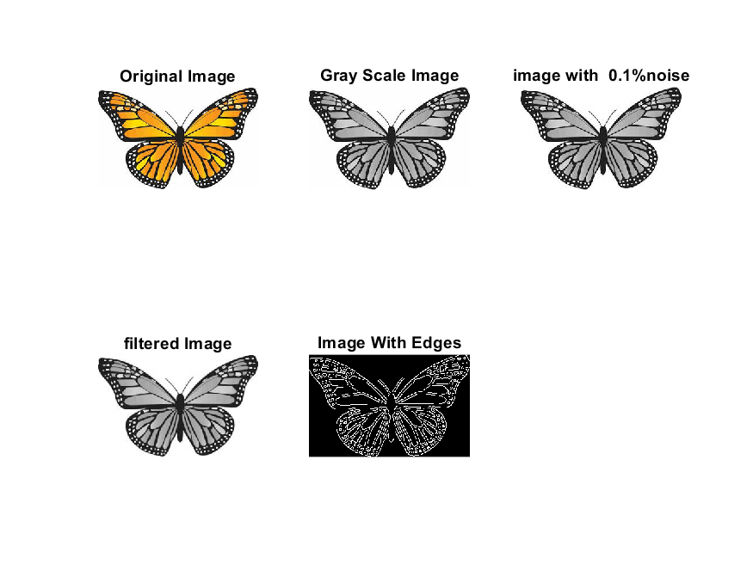

**Image 2:-10 % Noise**

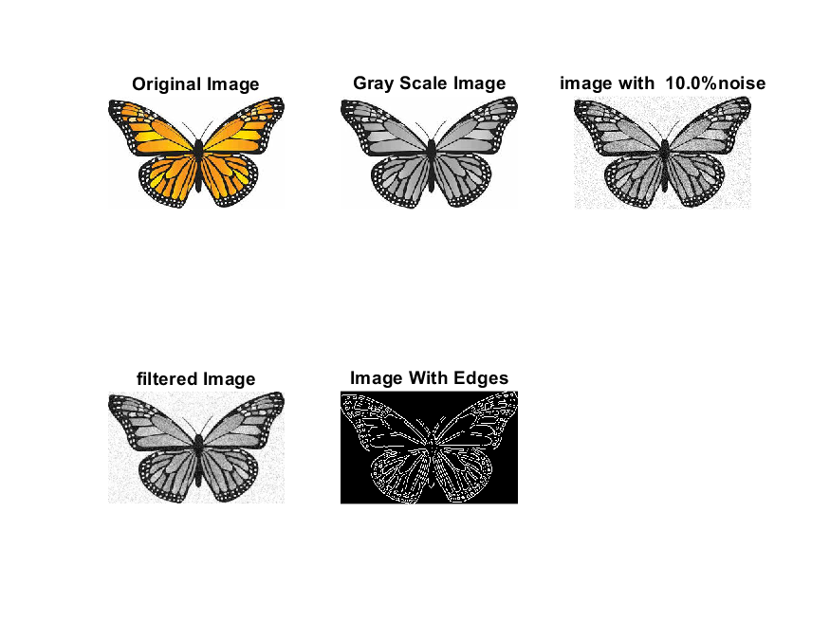

**Image 3:-20 % Noise**

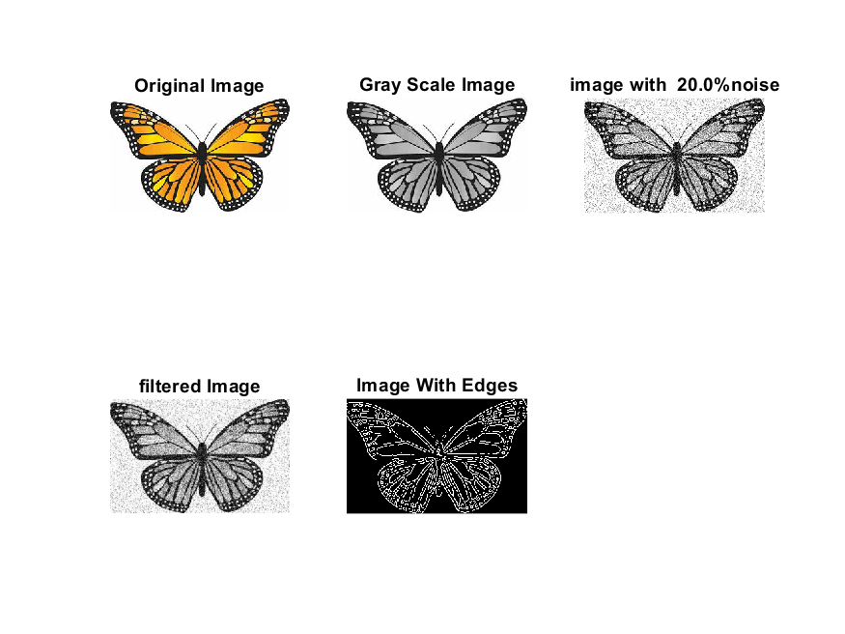

**Image 4:-30 % Noise**

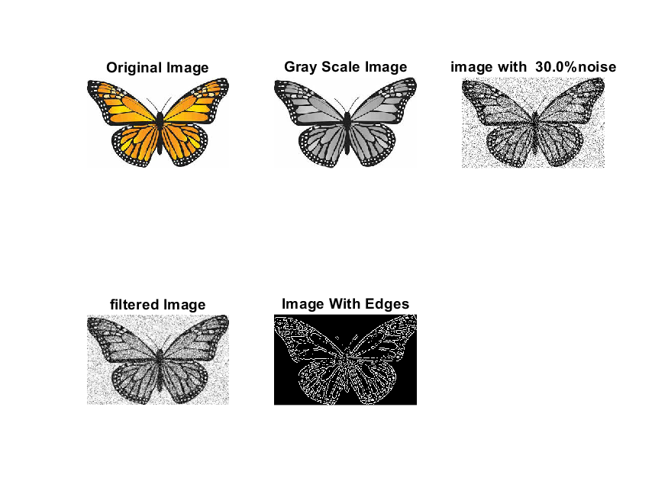

|  |
| --- |
| **Image 5:-40 % Noise** |

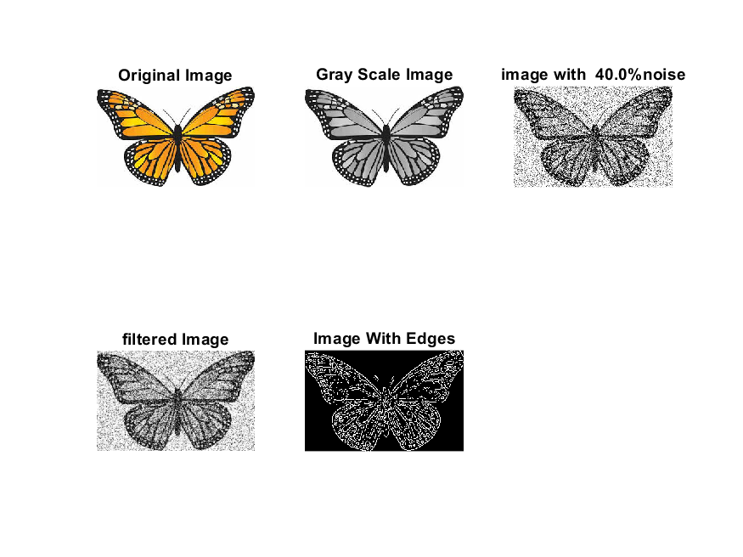

**Image 6:-50 % Noise**

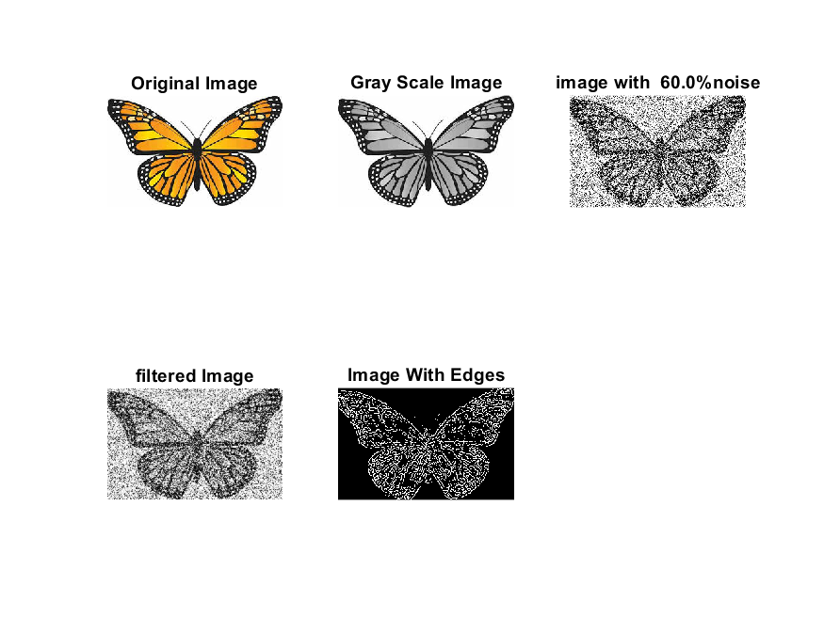

**Image 7:-60 % Noise**



**Image 8:-70 % Noise**

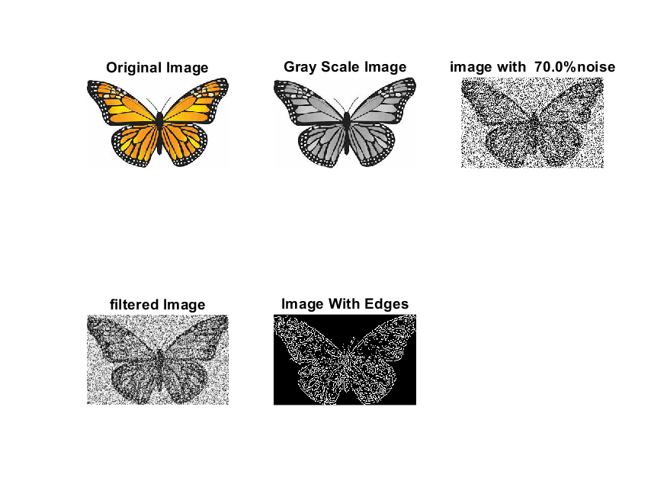

**Image 9:-80 % Noise**

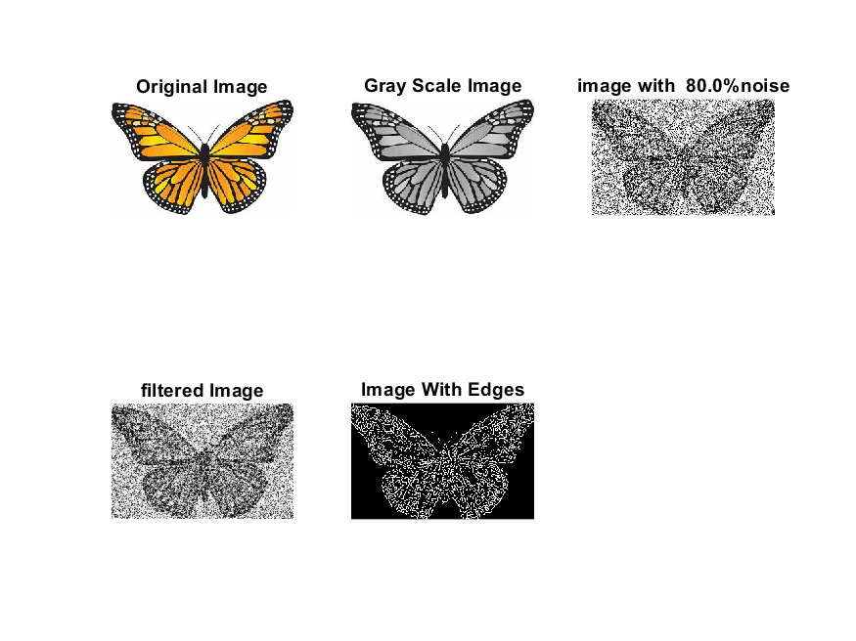

**DATA FILES**

**Image 1:-Noise0.1**

Original image ideal values:

IM1 image entropy:5.725024e-01

IM1 image mean:0.135564

Ground truth image entropy:0.968631

Ground truth image mean:0.396113

entropy between imt and im1 :0.901822

MSE between imt and im1 :0.374777

Average Difference between imt and im1 :0.260549

Maximum Difference between imt and im1 :1.000000

True Positive values:3960.000000

False Positive values: 2883.000000

True Negative values:27600.000000

False Negative values:16035.000000

Accuracy value: 0.625223

F Measure values:0.295104

Peak Signal-to Noise Ration value: 4.262269

Signal-to Noise Ration value: -4.656749

percentage of pixels that were correctly detected (Pco): 0.198050

The percentage of pixels that were not detected (Pnd):0.801950

the percentage of false alarm: (Pfa):0.144186

Euclidean Distance Value :18.841098

**Image 2:-Noise10**

Original image ideal values:

IM1 image entropy:5.712302e-01

IM1 image mean:0.135089

Ground truth image entropy:0.968631

Ground truth image mean:0.396113

entropy between imt and im1 :0.901669

MSE between imt and im1 :0.374024

Average Difference between imt and im1 :0.261025

Maximum Difference between imt and im1 :1.000000

True Positive values:3967.000000

False Positive values: 2852.000000

True Negative values:27631.000000

False Negative values:16028.000000

Accuracy value: 0.625976

F Measure values:0.295890

Peak Signal-to Noise Ration value: 4.271001

Signal-to Noise Ration value: -4.672007

percentage of pixels that were correctly detected (Pco): 0.198400

The percentage of pixels that were not detected (Pnd):0.801600

the percentage of false alarm: (Pfa):0.142636

Euclidean Distance Value :18.876001

**Image 3:-Noise20**

Original image ideal values:

IM1 image entropy:5.759339e-01

IM1 image mean:0.136852

Ground truth image entropy:0.968631

Ground truth image mean:0.396113

entropy between imt and im1 :0.900088

MSE between imt and im1 :0.372935

Average Difference between imt and im1 :0.259261

Maximum Difference between imt and im1 :1.000000

True Positive values:4039.000000

False Positive values: 2869.000000

True Negative values:27614.000000

False Negative values:15956.000000

Accuracy value: 0.627065

F Measure values:0.300264

Peak Signal-to Noise Ration value: 4.283672

Signal-to Noise Ration value: -4.615691

percentage of pixels that were correctly detected (Pco): 0.202001

The percentage of pixels that were not detected (Pnd):0.797999

the percentage of false alarm: (Pfa):0.143486

Euclidean Distance Value :19.235150

**Image 4:-Noise30**

Original image ideal values:

IM1 image entropy:5.904864e-01

IM1 image mean:0.142399

Ground truth image entropy:0.968631

Ground truth image mean:0.396113

entropy between imt and im1 :0.895398

MSE between imt and im1 :0.370161

Average Difference between imt and im1 :0.253714

Maximum Difference between imt and im1 :1.000000

True Positive values:4249.000000

False Positive values: 2939.000000

True Negative values:27544.000000

False Negative values:15746.000000

Accuracy value: 0.629839

F Measure values:0.312622

Peak Signal-to Noise Ration value: 4.316090

Signal-to Noise Ration value: -4.443133

percentage of pixels that were correctly detected (Pco): 0.212503

The percentage of pixels that were not detected (Pnd):0.787497

the percentage of false alarm: (Pfa):0.146987

Euclidean Distance Value :20.282873

**Image 4:-Noise30**

Original image ideal values:

IM1 image entropy:6.135608e-01

IM1 image mean:0.151492

Ground truth image entropy:0.968631

Ground truth image mean:0.396113

entropy between imt and im1 :0.888004

MSE between imt and im1 :0.366536

Average Difference between imt and im1 :0.244621

Maximum Difference between imt and im1 :1.000000

True Positive values:4570.000000

False Positive values: 3077.000000

True Negative values:27406.000000

False Negative values:15425.000000

Accuracy value: 0.633464

F Measure values:0.330656

Peak Signal-to Noise Ration value: 4.358835

Signal-to Noise Ration value: -4.174303

percentage of pixels that were correctly detected (Pco): 0.228557

The percentage of pixels that were not detected (Pnd):0.771443

the percentage of false alarm: (Pfa):0.153888

Euclidean Distance Value :21.884554

**Image 5:-Noise40**

Original image ideal values:

IM1 image entropy:6.312449e-01

IM1 image mean:0.158723

Ground truth image entropy:0.968631

Ground truth image mean:0.396113

entropy between imt and im1 :0.881547

MSE between imt and im1 :0.363029

Average Difference between imt and im1 :0.237391

Maximum Difference between imt and im1 :1.000000

True Positive values:4841.000000

False Positive values: 3171.000000

True Negative values:27312.000000

False Negative values:15154.000000

Accuracy value: 0.636971

F Measure values:0.345699

Peak Signal-to Noise Ration value: 4.400582

Signal-to Noise Ration value: -3.971805

percentage of pixels that were correctly detected (Pco): 0.242111

The percentage of pixels that were not detected (Pnd):0.757889

the percentage of false alarm: (Pfa):0.158590

Euclidean Distance Value :23.238957

**Image 6:-Noise50**

Original image ideal values:

IM1 image entropy:6.312449e-01

IM1 image mean:0.158723

Ground truth image entropy:0.968631

Ground truth image mean:0.396113

entropy between imt and im1 :0.881547

MSE between imt and im1 :0.363029

Average Difference between imt and im1 :0.237391

Maximum Difference between imt and im1 :1.000000

True Positive values:4841.000000

False Positive values: 3171.000000

True Negative values:27312.000000

False Negative values:15154.000000

Accuracy value: 0.636971

F Measure values:0.345699

Peak Signal-to Noise Ration value: 4.400582

Signal-to Noise Ration value: -3.971805

percentage of pixels that were correctly detected (Pco): 0.242111

The percentage of pixels that were not detected (Pnd):0.757889

the percentage of false alarm: (Pfa):0.158590

Euclidean Distance Value :23.238957

**Image 7:-Noise60**

Original image ideal values:

IM1 image entropy:6.338601e-01

IM1 image mean:0.159812

Ground truth image entropy:0.968631

Ground truth image mean:0.396113

entropy between imt and im1 :0.879091

MSE between imt and im1 :0.360117

Average Difference between imt and im1 :0.236301

Maximum Difference between imt and im1 :1.000000

True Positive values:4942.000000

False Positive values: 3125.000000

True Negative values:27358.000000

False Negative values:15053.000000

Accuracy value: 0.639883

F Measure values:0.352220

Peak Signal-to Noise Ration value: 4.435560

Signal-to Noise Ration value: -3.942094

percentage of pixels that were correctly detected (Pco): 0.247162

The percentage of pixels that were not detected (Pnd):0.752838

the percentage of false alarm: (Pfa):0.156289

Euclidean Distance Value :23.742007

**Image 8:-Noise70**

Original image ideal values:

IM1 image entropy:6.412554e-01

IM1 image mean:0.162922

Ground truth image entropy:0.968631

Ground truth image mean:0.396113

entropy between imt and im1 :0.877446

MSE between imt and im1 :0.360573

Average Difference between imt and im1 :0.233191

Maximum Difference between imt and im1 :1.000000

True Positive values:5009.000000

False Positive values: 3215.000000

True Negative values:27268.000000

False Negative values:14986.000000

Accuracy value: 0.639427

F Measure values:0.355009

Peak Signal-to Noise Ration value: 4.430069

Signal-to Noise Ration value: -3.858383

percentage of pixels that were correctly detected (Pco): 0.250513

The percentage of pixels that were not detected (Pnd):0.749487

the percentage of false alarm: (Pfa):0.160790

Euclidean Distance Value :24.076572

**Image 9:-Noise80**

Original image ideal values:

IM1 image entropy:6.489634e-01

IM1 image mean:0.166211

Ground truth image entropy:0.968631

Ground truth image mean:0.396113

entropy between imt and im1 :0.874744

MSE between imt and im1 :0.359543

Average Difference between imt and im1 :0.229902

Maximum Difference between imt and im1 :1.000000

True Positive values:5118.000000

False Positive values: 3272.000000

True Negative values:27211.000000

False Negative values:14877.000000

Accuracy value: 0.640457

F Measure values:0.360613

Peak Signal-to Noise Ration value: 4.442494

Signal-to Noise Ration value: -3.771594

percentage of pixels that were correctly detected (Pco): 0.255964

The percentage of pixels that were not detected (Pnd):0.744036

the percentage of false alarm: (Pfa):0.163641

Euclidean Distance Value :24.622069